Kentucky High School Athletic Association – Track & Field Site Inspection
______________________ High School, ________________, Kentucky
Site Inspection Requested by . . . . . Julian Tackett, Commissioner of KHSAA
Site Inspected by . _____________________ - #_______ – KHSAA Track and Field Consultant

Date of Inspection: Thursday, March 30, 2006

Venue # 1 . . . . . Running Tracks
Lanes (Number and Size)
General overall condition and concerns with the running track
Starting Lines  (Staggers) | 1 – Turn Stagger . . . . . 2 – Turn Stagger . . . . .  3 – Turn Stagger . . . . . 4 – Turn Stagger . . . .  Distance races . . . . .
Relay  Exchange Zone  Markings | The 4 x 100 Meter Relay  The 4 x 200 Meter .  The 4 X 400 Meter Relay  The 4 X 800 Meter Relay
Break Lines
Hurdles  Color Markings  Overall condition of  hurdles | :  100 Meter Hurdles . . . . .  110 Meter Hurdles . . . . .  300 Meter Hurdles . . . . .
Starting Blocks
(Number & Condition)
Starting Line
Safety
Finish Line
Safety
Surrounding area
(This could include bleachers, fencing, trees, limbs, etc.)

Location of Field Events
Track and Field Complex  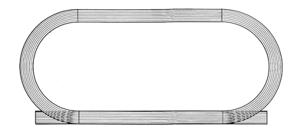  6  5  4  3  2 | Venue #2. Pole Vault is located.  Venue #3. High Jump is  Venue #4. Long and Triple Jump is located  Venue #5. Shot Put is located  Venue #6. Discus is

Venue #2 . . . . . Pole Vault
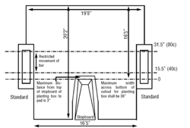 |  | . . . . . Pole Vault Landing Pad . . . . .  Width of Pole Vault Pad: 21’  Depth of Pole Vault Pad: 20’  Depth from the back of box: 16’5”  Common Cover: Yes  Weather Cover: Yes  Comments:
New PV Landing Pad
19’8” wide
20’2” deep
16’5” back of box
Vaulting Box

Zero Point Markings
Runway  130’0” | .
Standards / Crossbars
13’8” – 14’8”
Bar – 14’10”
Weigh in Athletes | It is pointed out that the host school is responsible to provide scales for the KHSAA Meet Official to weigh all the vaulters before each competition. It is highly recommended that each coach weigh his or her vaulters weekly to assure that they are legal for the vaulting poles that they are using.
Coaching Box
Area surrounding the Pole Vault Venue
Pole Vault Venue
(General Notes)

Venue # 3 . . . . . High Jump
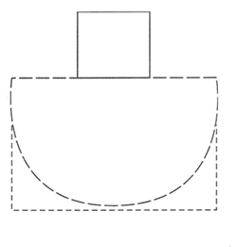 |  | . . . . . High Jump Pad and Apron . . . . .  Width of High Jump Pad: 20’  Depth of the High Jump Pad: 8’  Common Cover: Yes  Weather Cover: Yes  Apron Length: 100’  Apron Width: 50’  Comments: Whitley County has two high jump aprons that are of equal size and the competition could be head at either location.
HJ Landing Pad
16’ x 8’

Exposed Surfaces
HJ Apron
Standards / Crossbar  12’ apart  bar is 12’ to 14’10” | .
Area surrounding the
HJ Venue
High Jump Venue
(General Notes)

Venue # 4 . . . . . Long and Triple Jump
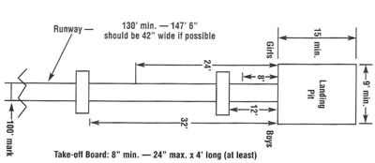 |  | . . . . . Long and Triple Jump Pits . . . . .  Number of Sand Pits: One  Length of Pit: #1 – _____ #2 _______  Width of Pit: #1 – _____ #2_______  Length of Runway: #1 – _____ #2 _______  LJ Take off Marks:#1 – _____ _____ _____ _____ _____ _____  TJ Take off Marks:#1 – _____ _____ _____ _____ _____ _____  Comments:
Landing Pit
Take Off Marks
LJ - (8’ and 12’)
TJ – (28’ and 32”)
And the Runway
Sand Pit
Condition
Area around the Long and Triple Jump Pit(s)
Long and Triple Jump
Venue
(General Notes)

Venue #5 . . . . . Shot Put
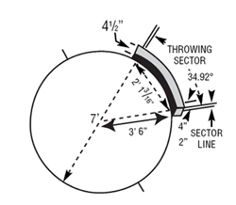  Old Sector |  | 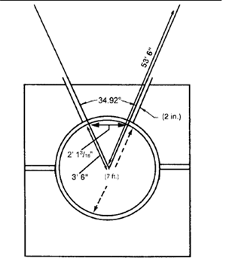  40 Degree Sector | New Sector . . . . .34.92  Step # 1. . . From the center of the 7-foot Shot Put circle, measure one of the outer boundary lines 20 meters and make a Mark #1 on the sector line.  Step # 2 . . . Measure 12 meters (.6 of the 20 Meter boundary line) from Mark #1 toward the other boundary line and make Mark #2.  Step # 3 . . . From the center of the Shot Put circle, measure 20 Meters out the 2nd boundary line and align this 20 Meter measurement with Mark #2 and the center of the circle and you will have your 34.92 sector.
Circle – Concrete Pad

Sector and Cage

Weight in of Implements | It is pointed out that the host school is responsible to provide scales for the KHSAA Meet Official to weigh all the throwing implements before each competition. It is highly recommended that each coach weigh his or her athletes implements weekly to assure that they are legal and that no alterations have been made to the implements.
Surrounding Area
Shot Put  Venue  (General Notes) | .

Venue #6 . . . . . Discus Throw
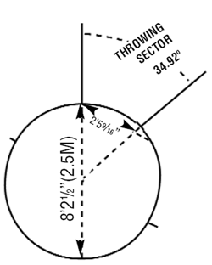  Old Sector | 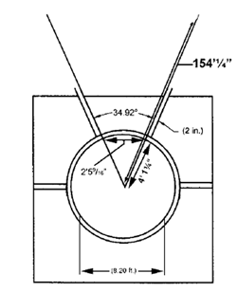  40 Degree Sector | New Sector . . . . . 34.92  Step #1 . . . From the center of the 8 foot 2 ½” circle, measure one of the outer boundary lines 60 meters and make a Mark #1 on the sector line.  Step # 2 . . . Measure 26 meters (.6 of the 60 Meter boundary line) from Mark #1 toward the other boundary line and make Mark #2.  Step #3 . . .From the center of the Discus circle, measure 60 Meters out the 2nd boundary line and align this 60 Meter measurement with Mark #2 and the center of the circle and you will have your 34.92 sector.
Circle – Concrete Pad
Sector and Cage
Weight in of Implements | It is pointed out that the host school is responsible to provide scales for the KHSAA Meet Official to weigh all the throwing implements before each competition. It is highly recommended that each coach weigh his or her athletes implements weekly to assure that they are legal and that no alterations have been made to the implements.
Surrounding Area
Discus Venue  (General Notes) | .

Meet Management
Seating and Spectator Control
Public Address and
Press Box
Meet Management
in regard to
Running Events
Meet Management
in regard to
Field Events
Regional Meet
Site
In your opinion would you recommend this facility to be considered as a Regional Track and Field Meet Site?

Respectively submitted,

______________________, #_______
KHSAA Track and Field Consultant

